Assignment 8
Title: Contact List Management using Binary Search Tree

Name: Soham Ajit Puri
Roll. No: 04
Branch: CSDS_C1

Problem Statement: Create a contact list where names are stored and retrieved using a Binary Search Tree. Implement insertion, deletion, and search features.

Theory:
A Binary Search Tree (BST) is a hierarchical data structure where each node contains a data value (in this case, a contact name) and pointers to left and right child nodes. The left child contains values smaller than the parent, and the right child contains values greater than the parent. This property allows efficient searching, insertion, and deletion operations.
In this assignment, we use a BST to manage a Contact List. The contacts are stored in lexicographic (alphabetical) order automatically because of the BST structure.
- Insertion: A new contact is added to the correct position by comparing its name with existing nodes.
- Searching: A given contact name is located by traversing the tree according to BST rules.
- Deletion: A contact can be removed by handling three possible cases:
  - Node has no children (leaf node).
  - Node has one child.
  - Node has two children, where the inorder successor is used for replacement.
- Traversal (Inorder): Displays all contacts in sorted order.
This approach ensures that the contact list remains organized, sorted, and efficient to access. The BST operations generally take O(log n) time on average, making it suitable for managing large sets of contacts.
Algorithm:

Step 1: Define Node Structure
- Each node contains:
- name (string)
- left pointer → points to left child
- right pointer → points to right child

Step 2: InsertName(root, name)
- If root is NULL:
  - Create a new node with the given name
  - Return the new node
- Else compare name with root->name:
- If name < root->name: recursively insert into the left subtree
- Else if name > root->name: recursively insert into the right subtree
- Else (duplicate): ignore insertion
- Return updated root

Step 3: SearchName(root, name)
- If root is NULL → return false (not found)
- If root->name == name → return true (found)
- Else if name < root->name → search in left subtree
- Else → search in right subtree

Step 4: FindMin(root)
- Start from root
- While root->left is not NULL:
  - Move to root->left
- Return the leftmost node (smallest name)

Step 5: DeleteName(root, name)
- If root is NULL → return NULL
- If name < root->name:
  - Recurse on left subtree
- Else if name > root->name:
  - Recurse on right subtree
- Else (found node to delete):
  - Case A: Leaf node → delete it and return NULL
  - Case B: One child → replace node with its non-null child

  - Case C: Two children →
    - Find inorder successor = minimum node in right subtree
    - Copy successor’s name into current node
    - Recursively delete successor node from right subtree
- Return updated root

Step 6: InorderTraversal(root)
- If root is NULL → return
- Recursively call inorder on left subtree
- Visit current node (print root->name)
- Recursively call inorder on right subtree
  - This prints all contacts in ascending order

Step 7: Main Menu Program
- Initialize root = NULL
- Repeat until user chooses Exit:
- Display menu:
  - Insert Contact
  - Search Contact
  - Delete Contact
  - Display All Contacts
  - Exit
- Read user’s choice
- Perform corresponding operation by calling functions
- End program when choice = Exit.

CODE:
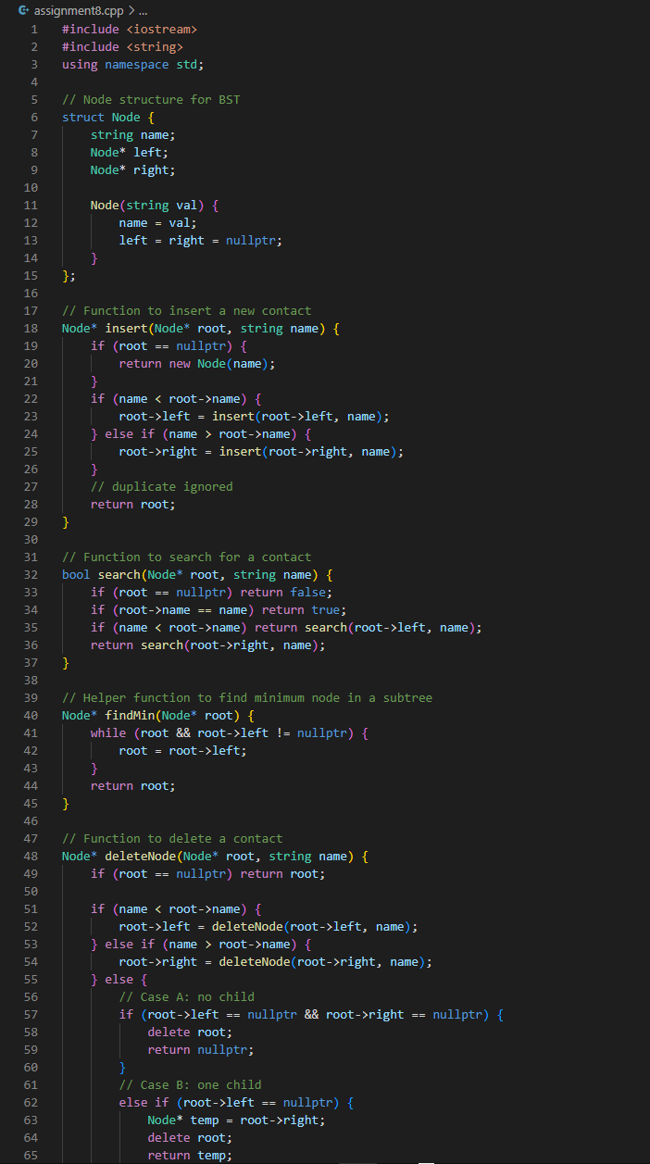
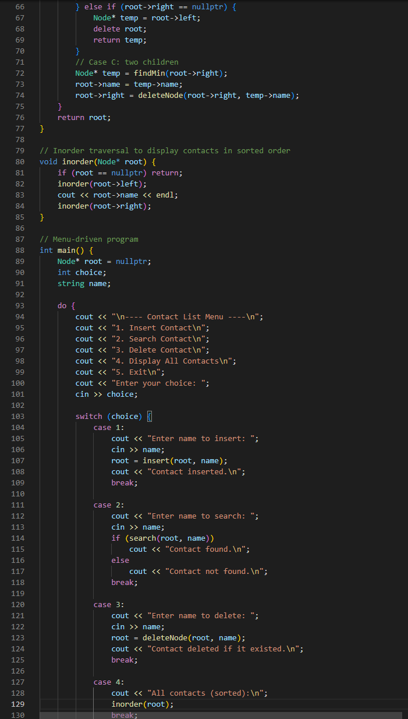
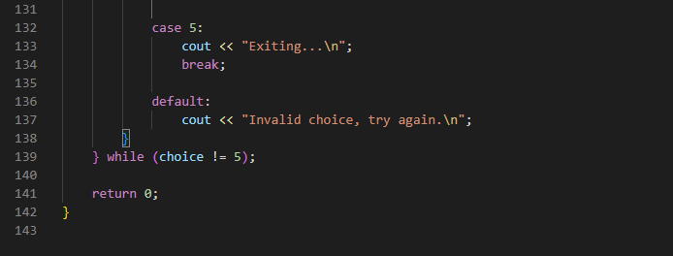

RESULTs:

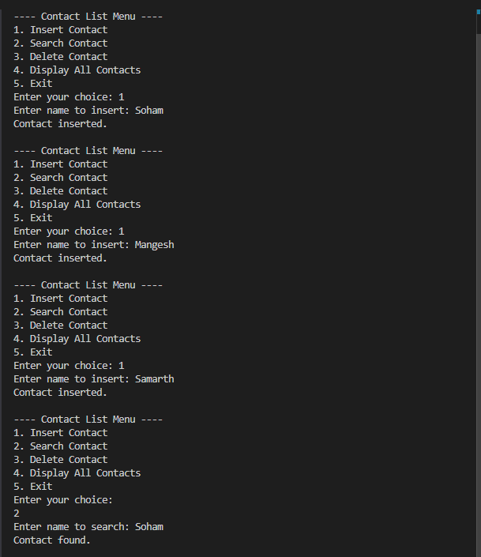
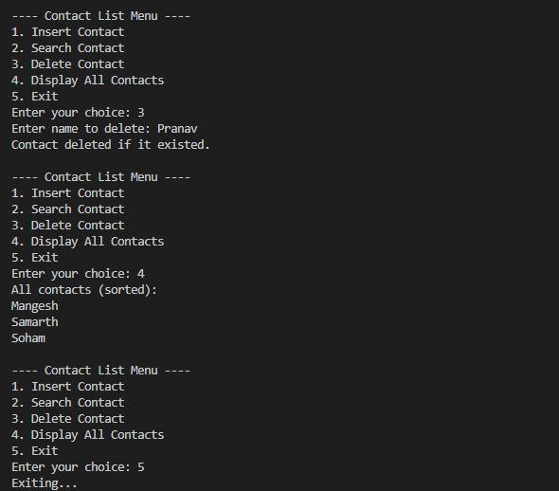

Conclusion:
The implementation of a Contact List using Binary Search Tree successfully demonstrates how tree-based data structures can be applied to manage and organize data efficiently. By using BST properties, the program is able to insert, search, delete, and display contacts in sorted order with ease. The menu-driven approach makes the system interactive and user-friendly. Overall, this assignment highlights the importance of BST in real-world applications such as contact management, where quick access and systematic arrangement of information are essential.

